Unit-1

THE EVOLVING ROLE OF SOFTWARE
Today, software takes on a dual role. It is a product and, at the same time, the vehicle for delivering a product. As a product, it delivers the computing potential embodied by computer hardware or, more broadly, a network of computers that are accessible by local hardware. The lone programmer of an earlier era has been replaced by a team of software specialists, each focusing on one part of the technology required to deliver a complex application. And yet, the same questions asked of the lone programmer are being asked when modern computer-based systems are built:
• Why does it take so long to get software finished?
• Why are development costs so high?
• Why can't we find all the errors before we give the software to customers?
• Why do we continue to have difficulty in measuring progress as software is
being developed?

Software Characteristics
Software is a logical rather than a physical system element. Therefore, software has characteristics that are considerably different than those of hardware:

1. Software is developed or engineered, it is not manufactured in the classical sense.
2. Software doesn't "wear out."
3. Although the industry is moving toward component-based assembly, most software continues to be custom built.

Software Applications
Software may be applied in any situation for which a prespecified set of procedural steps (i.e., an algorithm) has been defined. It is somewhat difficult to develop meaningful generic categories for software applications. As software complexity grows, neat compartmentalization disappears. The following software areas indicate the breadth of potential applications:

System software. System software is a collection of programs written to service other programs. Some system software (e.g., compilers, editors, and file management utilities) process complex, but determinate, information structures. Other systems applications (e.g. operating system components, drivers, telecommunications processors) process largely indeterminate data. In either case, the system software area is characterized by heavy interaction with computer hardware; heavy usage by multiple users; concurrent operation that requires scheduling, resource sharing, and sophisticated process management; complex data structures; and multiple external interfaces.
Real-time software. Software that monitors/analyzes/controls real-world events as they occur is called real time. Elements of real-time software include a data gathering component that collects and formats information from an external environment, an analysis component that transforms information as required by the application, a control/output component that responds to the external environment, and a monitoring component that coordinates all other components so that real-time response (typically ranging from 1 millisecond to 1 second) can be maintained.
Business software. Business information processing is the largest single software application area. Discrete "systems" (e.g., payroll, accounts receivable/payable, inventory) have evolved into management information system (MIS) software that accesses one or more large databases containing business information. Applications in this area restructure existing data in a way that facilitates business operations or management decision making. In addition to conventional data processing application, business software applications also encompass interactive computing (e.g., pointofsale transaction processing).
Engineering and scientific software. Engineering and scientific software have been characterized by "number crunching" algorithms. Applications range from astronomy to volcanology, from automotive stress analysis to space shuttle orbital dynamics, and from molecular biology to automated manufacturing. However, modern applications within the engineering/scientific area are moving away from conventional numerical algorithms. Computer-aided design, system simulation, and other interactive applications have begun to take on real-time and even system software characteristics.
Embedded software. Intelligent products have become commonplace in nearly every consumer and industrial market. Embedded software resides in read-only memory and is used to control products and systems for the consumer and industrial markets.
Embedded software can perform very limited and esoteric functions (e.g., keypad control for a microwave oven) or provide significant function and control capability (e.g., digital functions in an automobile such as fuel control, dashboard displays, and braking systems).
Personal computer software. The personal computer software market has burgeoned over the past two decades. Word processing, spreadsheets, computer graphics, multimedia, entertainment, database management, personal and business financial applications, external network, and database access are only a few of hundreds of applications.
Web-based software. The Web pages retrieved by a browser are software that incorporates executable instructions (e.g., CGI, HTML, Perl, or Java), and data (e.g., hypertext and a variety of visual and audio formats). In essence, the network becomes a massive computer providing an almost unlimited software resource that can be accessed by anyone with a modem.
Artificial intelligence software. Artificial intelligence (AI) software makes use of non numerical algorithms to solve complex problems that are not amenable to computation or straightforward analysis. Expert systems, also called knowledge based systems, pattern recognition (image and voice), artificial neural networks, theorem proving, and game playing are representative of applications within this category.

SOFTWARE MYTHS
Management myths. Managers with software responsibility, like managers in most disciplines, are often under pressure to maintain budgets, keep schedules from slipping, and improve quality. Like a drowning person who grasps at a straw, a software manager often grasps at belief in a software myth, if that belief will lessen the pressure (even temporarily).

Myth: We already have a book that's full of standards and procedures for building software, won't that provide my people with everything they need to know?
Reality: The book of standards may very well exist, but is it used? Are software practitioners aware of its existence? Does it reflect modern software engineering practice? Is it complete? Is it streamlined to improve time to delivery while still maintaining
a focus on quality? In many cases, the answer to all of these questions is "no."

Myth: My people have state-of-the-art software development tools, after all, we buy them the newest computers.
Reality: It takes much more than the latest model mainframe, workstation, or PC to do high-quality software development. Computer-aided software engineering (CASE) tools are more important than hardware for achieving good quality and productivity, yet the majority of software developers still do not use them effectively.

Myth: If we get behind schedule, we can add more programmers and catch up (sometimes called the Mongolian horde concept).
Reality: Software development is not a mechanistic process like manufacturing.
Myth: If I decide to outsource the software project to a third party, I can just relax and let that firm build it.
Reality: If an organization does not understand how to manage and control software projects internally, it will invariably struggle when it outsource software projects.

Customer myths. A customer who requests computer software may be a person at the next desk, a technical group down the hall, the marketing/sales department, or an outside company that has requested software under contract. In many cases, the customer believes myths about software because software managers and practitioners do little to correct misinformation. Myths lead to false expectations (by the customer) and ultimately, dissatisfaction with the developer.

Myth: A general statement of objectives is sufficient to begin writing programs we can fill in the details later.
Reality: A poor up-front definition is the major cause of failed software efforts. A formal and detailed description of the information domain, function, behavior, performance, interfaces, design constraints, and validation criteria is essential. These characteristics can be determined only after thorough communication between customer and developer.

Myth: Project requirements continually change, but change can be easily accommodated because software is flexible.

Reality: It is true that software requirements change, but the impact of change varies with the time at which it is introduced.

Practitioner's myths. Myths that are still believed by software practitioners have been fostered by 50 years of programming culture. During the early days of software, programming was viewed as an art form. Old ways and attitudes die hard.

Myth: Once we write the program and get it to work, our job is done.
Reality: Someone once said that "the sooner you begin 'writing code', the longer it'll take you to get done. Industry data indicate that between 60 and 80 percent of all effort expended on software will be expended after it is delivered to the customer for the first time.

Myth: Until I get the program "running" I have no way of assessing its quality.
Reality: One of the most effective software quality assurance mechanisms can be applied from the inception of a project—the formal technical review. Software reviews are a "quality filter" that have been found to be more effective than testing for finding certain classes of software defects.

Myth: The only deliverable work product for a successful project is the working program.
Reality: A working program is only one part of a software configuration that includes many elements. Documentation provides a foundation for successful engineering and, more important, guidance for software support.

Myth: Software engineering will make us create voluminous and unnecessary documentation and will invariably slow us down.
Reality: Software engineering is not about creating documents. It is about creating quality. Better quality leads to reduced rework. And reduced rework results in faster delivery times.
Summary
Software has become the key element in the evolution of computer-based systems and products. Over the past 50 years, software has evolved from a specialized problem solving and information analysis tool to an industry in itself. But early “programming” culture and history have created a set of problems that persist today. Software has become the limiting factor in the continuing evolution of computer based systems. Software is composed of programs, data, and documents. Each of these items comprises a configuration that is created as part of the software engineering process. The intent of software engineering is to provide a framework for building software with higher quality.
Unit-2

Definition Of software engineering
The IEEE [IEE93] has developed a more comprehensive definition when it states: Software Engineering: (1) The application of a systematic, disciplined, quantifiable approach to the development, operation, and maintenance of software; that is, the application of engineering to software. (2) The study of approaches as in (1).

Process, Methods, and Tools
Software engineering is a layered technology. Referring to Figure, any engineering approach (including software engineering) must rest on an organizational commitment to quality. Total quality management and similar philosophies foster a continuous process improvement culture, and this culture ultimately leads to the development of increasingly more mature approaches to software engineering. The bedrock that supports software engineering is a quality focus. The foundation for software engineering is the process layer. Software engineering process is the glue that holds the technology layers together and enables rational and timely development of computer software. Process defines a framework for a set of key process areas (KPAs) that must be established for effective delivery of software engineering technology. The key process areas form the basis for management control of software projects and establish the context in which technical methods are applied, work products (models, documents, data, reports, forms, etc.) are produced, milestones are established, quality is ensured, and change is properly managed.



Software engineering methods provide the technical how-to's for building software. Methods encompass a broad array of tasks that include requirements analysis, design, program construction, testing, and support. Software engineering methods rely on a set of basic principles that govern each area of the technology and include modeling activities and other descriptive techniques.

Software engineering tools provide automated or semi-automated support for the process and the methods. When tools are integrated so that information created by one tool can be used by another, a system for the support of software development, called computer-aided software engineering, is established. CASE combines software, hardware, and a software engineering database (a repository containing important information about analysis, design, program construction, and testing) to create a software engineering environment analogous to CAD/CAE (computer-aided design/engineering) for hardware.

A Generic View of Software Engineering
Engineering is the analysis, design, construction, verification, and management of technical (or social) entities. Regardless of the entity to be engineered, the following questions must be asked and answered:

• What is the problem to be solved?
• What characteristics of the entity are used to solve the problem?
• How will the entity (and the solution) be realized?
• How will the entity be constructed?
• What approach will be used to uncover errors that were made in the design and construction of the entity?
• How will the entity be supported over the long term, when corrections, adaptations, and enhancements are requested by users of the entity.

The work associated with software engineering can be categorized into three generic phases, regardless of application area, project size, or complexity. Each phase addresses one or more of the questions noted previously.
The definition phase focuses on what.
The development phase focuses on how.
The support phase focuses on change associated with error correction, adaptations required as the software's environment evolves, and changes due to enhancements brought about by changing customer requirements. Four types of change are encountered during the support phase Correction, Adaptation, Enhancement, Prevention. The phases and related steps described in our generic view of software engineering are complemented by a number of umbrella activities. Typical activities in this category include:

• Software project tracking and control
• Formal technical reviews
• Software quality assurance
• Software configuration management
• Document preparation and production
• Reusability management
• Measurement
• Risk management

THE SOFTWARE PROCESS
A software process can be characterized as shown in Figure. A common process framework is established by defining a small number of framework activities that are applicable to all software projects, regardless of their size or complexity. A number of task sets—each a collection of software engineering work tasks, project milestones, work products, and quality assurance points.

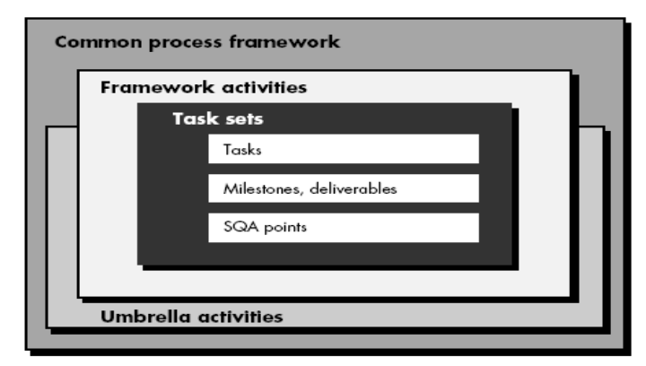

Capability Maturity Model (SEI-CMM)
The SEI approach provides a measure of the global effectiveness of a company's software engineering practices and establishes five process maturity levels that are defined in the following manner:

Level 1: Initial. The software process is characterized as ad hoc and occasionally even chaotic. Few processes are defined, and success depends on individual effort.
Level 2: Repeatable. Basic project management processes are established to track cost, schedule, and functionality. The necessary process discipline is in place to repeat earlier successes on projects with similar applications.
Level 3: Defined. The software process for both management and engineering activities is documented, standardized, and integrated into an organizationwide software process. All projects use a documented and approved version of the organization's process for developing and supporting software. This level includes all characteristics defined for level 2.
Level 4: Managed. Detailed measures of the software process and product quality are collected. Both the software process and products are quantitatively understood and controlled using detailed measures. This level includes all characteristics defined for level 3.
Level 5: Optimizing. Continuous process improvement is enabled by quantitative feedback from the process and from testing innovative ideas and technologies. This level includes all characteristics defined for level 4.

KPA at different level.

Process maturity level 1 – No KPA

Process maturity level 2
• Software configuration management
• Software quality assurance
• Software subcontract management
• Software project tracking and oversight
• Software project planning
• Requirements management
Process maturity level 3
• Peer reviews
• Intergroup coordination
• Software product engineering
• Integrated software management
• Training program
• Organization process definition
• Organization process focus
Process maturity level 4
• Software quality management
• Quantitative process management
Process maturity level 5
• Process change management
• Technology change management
• Defect prevention

SOFTWARE PROCESS MODELS
All software development can be characterized as a problem solving loop.

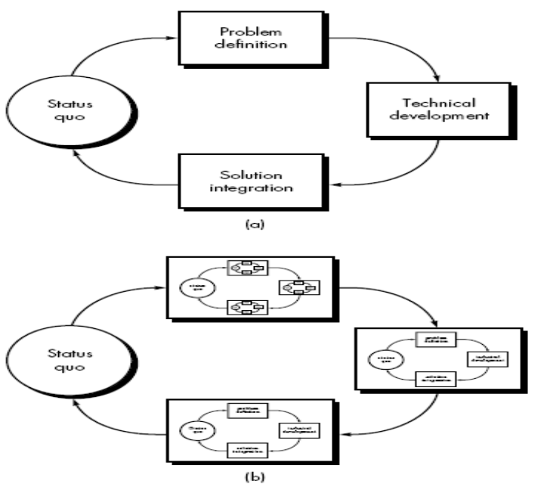

THE LINEAR SEQUENTIAL MODEL
Sometimes called the classic life cycle or the waterfall model, the linear sequential model suggests a systematic, sequential approach5 to software development that begins at the system level and progresses through analysis, design, coding, testing, and support. Figure illustrates the linear sequential model for software engineering. Modeled after a conventional engineering cycle, the linear sequential model encompasses the following activities:

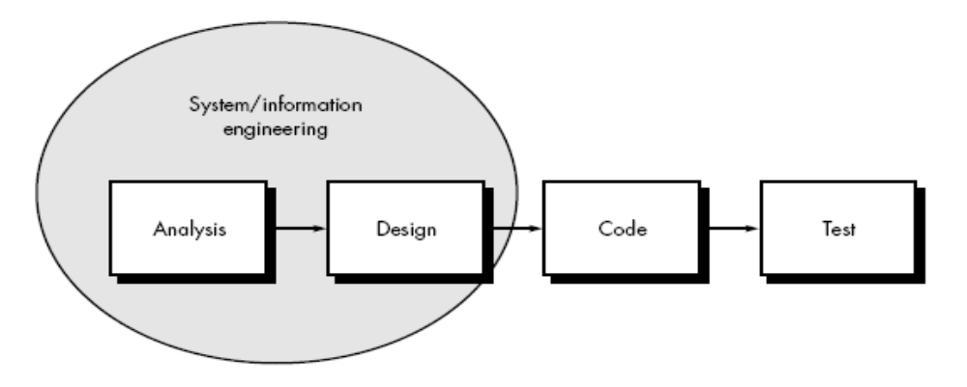
System/information engineering and modeling. Because software is always part of a larger system (or business), work begins by establishing requirements for all system elements and then allocating some subset of these requirements to software. This system view is essential when software must interact with other elements such as hardware, people, and databases. System engineering and analysis encompass requirements gathering at the system level with a small amount of top level design and analysis. Information engineering encompasses requirements gathering at the strategic business level and at the business area level.

Software requirements analysis. The requirements gathering process is intensified and focused specifically on software. To understand the nature of the program(s) to be built, the software engineer ("analyst") must understand the information domain for the software, as well as required function, behavior, performance, and interface. Requirements for both the system and the software are documented
and reviewed with the customer.

Design. Software design is actually a multistep process that focuses on four distinct attributes of a program: data structure, software architecture, interface representations, and procedural (algorithmic) detail. The design process translates requirements into a representation of the software that can be assessed for quality before coding begins. Like requirements, the design is documented and becomes part of the software configuration.
Code generation. The design must be translated into a machine-readable form. The code generation step performs this task. If design is performed in a detailed manner, code generation can be accomplished mechanistically.
Testing. Once code has been generated, program testing begins. The testing process focuses on the logical internals of the software, ensuring that all statements have been tested, and on the functional externals; that is, conducting tests to uncover errors and ensure that defined input will produce actual results that agree with required results.
Support. Software will undoubtedly undergo change after it is delivered to the customer (a possible exception is embedded software). Change will occur because errors have been encountered, because the software must be adapted to accommodate changes in its external environment (e.g., a change required because of a new operating system or peripheral device), or because the customer requires unctional or performance enhancements. Software support/maintenance reapplies each of the preceding phases to an existing program rather than a new one.

Problems with Linear Sequential Model
1. Real projects rarely follow the sequential flow that the model proposes. Although the linear model can accommodate iteration, it does so indirectly. As a result, changes can cause confusion as the project team proceeds.
2. It is often difficult for the customer to state all requirements explicitly. The linear sequential model requires this and has difficulty accommodating the natural uncertainty that exists at the beginning of many projects.
3. The customer must have patience. A working version of the program(s) will not be available until late in the project time-span. A major blunder, if undetected until the working program is reviewed, can be disastrous.

THE PROTOTYPING MODEL
The prototyping paradigm begins with requirements gathering. Developer and customer meet and define the overall objectives for the software, identify whatever requirements are known, and outline areas where further definition is mandatory. A "quick design" then occurs. The quick design focuses on a representation of those aspects of the software that will be visible to the customer/user (e.g., input approaches and output formats). The quick design leads to the construction of a prototype. The prototype is evaluated by the customer/user and used to refine requirements for the software to be developed. Iteration occurs as the prototype is tuned to satisfy the needs of the customer, while at the same time enabling the developer to better understand what needs to be done.
Ideally, the prototype serves as a mechanism for identifying software requirements. If a working prototype is built, the developer attempts to use existing program fragments or applies tools (e.g., report generators, window managers) that enable working programs to be generated quickly.
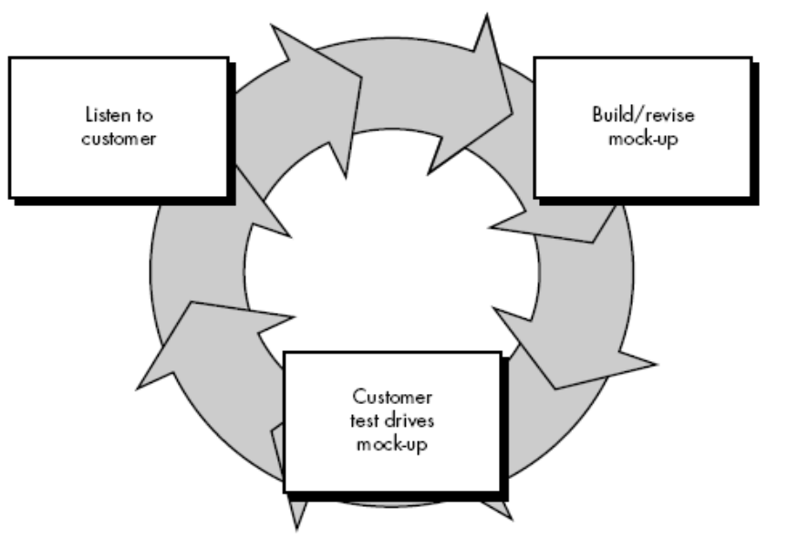

Problems with Prototyping
1. The customer sees what appears to be a working version of the software.
2. The developer often makes implementation compromises in order to get a prototype working quickly.

THE RAD MODEL

Rapid application development (RAD) is an incremental software development process
model that emphasizes an extremely short development cycle. The RAD model is a
“high-speed” adaptation of the linear sequential model in which rapid development is achieved by using component-based construction.

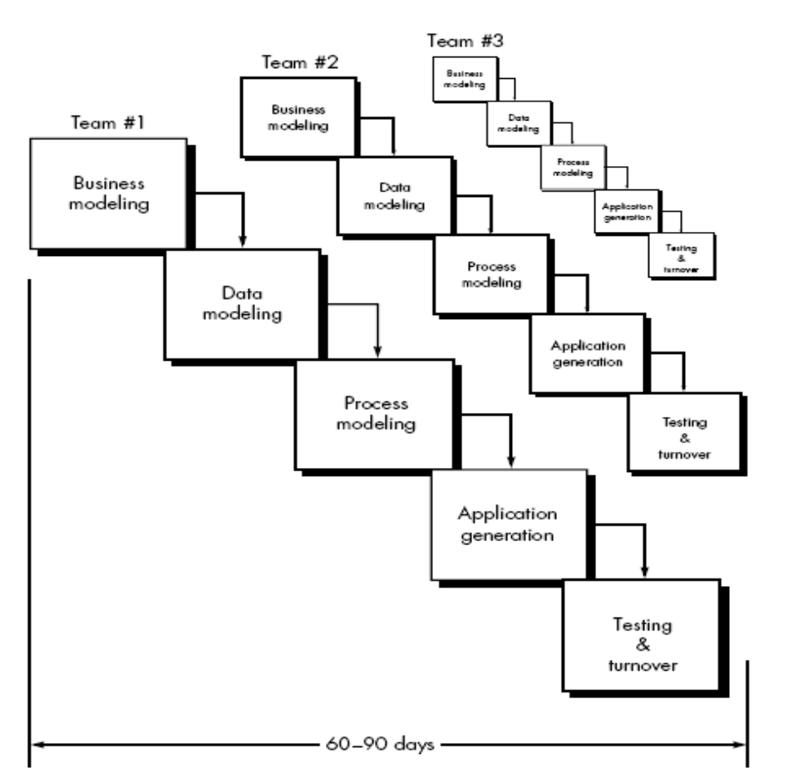

RAD approach encompasses the following phases:

Business modeling. The information flow among business functions is modeled in
a way that answers the following questions:
What information drives the business process?
\What information is generated?
Who generates it?
Where does the information go?
Who processes it?

Data modeling. The information flow defined as part of the business modeling phase
is refined into a set of data objects that are needed to support the business.

Process modeling. The data objects defined in the data modeling phase are transformed to achieve the information flow necessary to implement a business function.
Processing descriptions are created for adding, modifying, deleting, or retrieving a
data object.

Application generation. RAD assumes the use of fourth generation techniques.
Rather than creating software using conventional third generation programming languages the RAD process works to reuse existing program components or create reusable components.

Testing and turnover. Since the RAD process emphasizes reuse, many of the program
components have already been tested. This reduces overall testing time.

Drawbacks:

1. For large but scalable projects, RAD requires sufficient human resources to
create the right number of RAD teams.
2. If commitment is lacking from either constituency, RAD projects will fail.
3. If a system cannot be properly modularized, building the components necessary for RAD will be problematic.
4. If high performance is an issue and performance is to be achieved through tuning the interfaces to system components, the RAD approach may not work.
5. RAD is not appropriate when technical risks are high.

EVOLUTIONARY SOFTWARE PROCESS MODELS
Evolutionary models are iterative. They are characterized in a manner that enables software engineers to develop increasingly more complete versions of the software.

Incremental Model
The incremental model combines elements of the linear sequential model (applied repetitively) with the iterative philosophy of prototyping. The incremental model applies linear sequences in a staggered fashion as calendar time progresses. Each linear sequence produces a deliverable “increment” of the software.
When an incremental model is used, the first increment is often a core product. That is, basic requirements are addressed, but many supplementary features (some known, others unknown) remain undelivered. The core product is used by the customer (or undergoes detailed review). As a result of use and/or evaluation, a plan is developed for the next increment. The plan addresses the modification of the core product to better meet the needs of the customer and the delivery of additional features and functionality. This process is repeated following the delivery of each increment, until the complete product is produced.

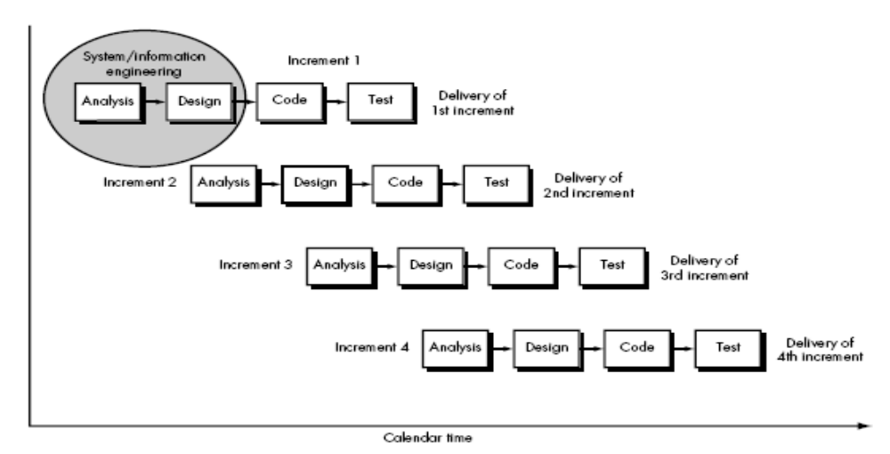

The Spiral Model
The spiral model, originally proposed by Boehm [BOE88], is an evolutionary software process model that couples the iterative nature of prototyping with the controlled and systematic aspects of the linear sequential model. It provides the potential for rapid development of incremental versions of the software. Using the spiral model, software is developed in a series of incremental releases. During early iterations, the incremental release might be a paper model or prototype. During later iterations, increasingly more complete versions of the engineered system are produced. A spiral model is divided into a number of framework activities, also called task regions.6 Typically, there are between three and six task regions. Figure depicts a spiral model that contains six task regions:
• Customer communication—tasks required to establish effective communication
between developer and customer.
• Planning—tasks required to define resources, timelines, and other project related
information.
• Risk analysis—tasks required to assess both technical and management risks.
• Engineering—tasks required to build one or more representations of the application.
• Construction and release—tasks required to construct, test, install, and provide user support (e.g., documentation and training).
• Customer evaluation—tasks required to obtain customer feedback based on evaluation of the software representations created during the engineering stage and implemented during the installation stage.
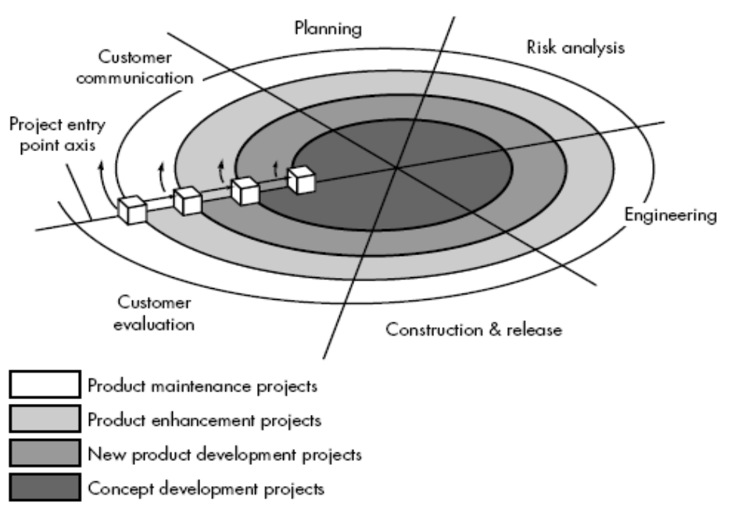
The spiral model is a realistic approach to the development of large-scale systems and software. Because software evolves as the process progresses, the developer and customer better understand and react to risks at each evolutionary level. The spiral model uses prototyping as a risk reduction mechanism but, more important, enables the developer to apply the prototyping approach at any stage in the evolution of the product. It maintains the systematic stepwise approach suggested by the classic life cycle but incorporates it into an iterative framework that more realistically reflects the real world. The spiral model demands a direct consideration of technical risks at all stages of the project and, if properly applied, should reduce risks before they become problematic.

The Concurrent Development Model
The concurrent development model, sometimes called concurrent engineering. The concurrent process model can be represented schematically as a series of major technical activities, tasks, and their associated states.

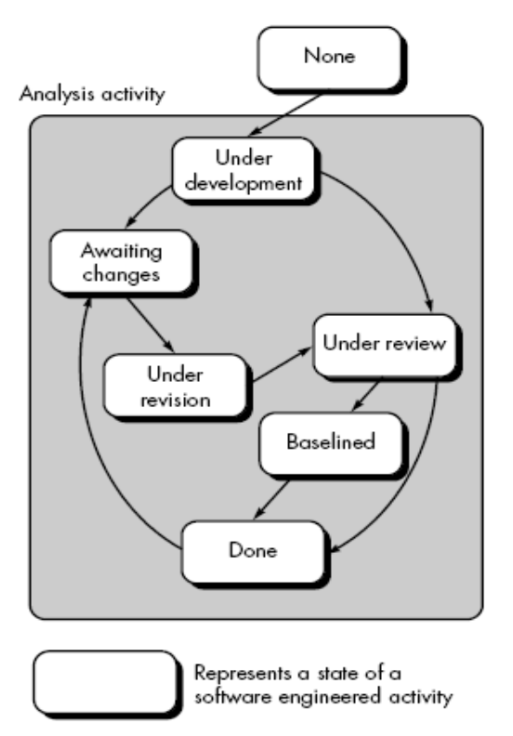
COMPONENT-BASED DEVELOPMENT
Object-oriented technologies provide the technical framework for a component-based process model for software engineering. The object oriented paradigm emphasizes the creation of classes that encapsulate both data and the algorithms used to manipulate the data. If properly designed and implemented, object-oriented classes are reusable across different applications and computer-based system architectures. The component-based development (CBD) model incorporates many of the characteristics of the spiral model. It is evolutionary in nature, demanding an iterative approach to the creation of software. However, the component-based development model composes applications from prepackaged software components (called classes). The engineering activity begins with the identification of candidate classes. This is accomplished by examining the data to be manipulated by the application and the algorithms that will be applied to accomplish the manipulation. Corresponding data and algorithms are packaged into a class. Classes created in past software engineering projects are stored in a class library or repository (Chapter 31). Once candidate classes are identified, the class library is searched to determine if these classes already exist. If they do, they are extracted from the library and reused. If a candidate class does not reside in the library, it is engineered using object-oriented methods.

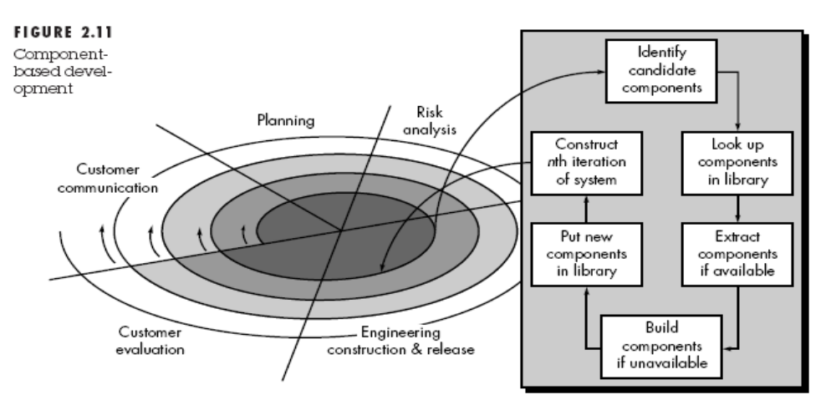

THE FORMAL METHODS MODEL
The formal methods model encompasses a set of activities that leads to formal mathematical specification of computer software. Formal methods enable a software engineer to specify, develop, and verify a computer-based system by applying a rigorous, mathematical notation. A variation on this approach, called cleanroom software engineering, is currently applied by some software development organizations. When formal methods are used during development, they provide a mechanism for eliminating many of the problems that are difficult to overcome using other software engineering paradigms. Ambiguity, incompleteness, and inconsistency can be discovered and corrected more easily, not through ad hoc review but through the application of mathematical analysis. When formal methods are used during design, they serve as a basis for program verification and therefore enable the software engineer to discover and correct errors that might go undetected. Although it is not destined to become a mainstream approach, the formal methods model offers the promise of defect-free software. Yet, the following concerns about its applicability in a business environment have been voiced:
1. The development of formal models is currently quite time consuming and expensive.
2. Because few software developers have the necessary background to apply formal methods, extensive training is required.
3. It is difficult to use the models as a communication mechanism for technically unsophisticated customers.

FOURTH GENERATION TECHNIQUES
The term fourth generation techniques (4GT) encompasses a broad array of software tools that have one thing in common: each enables the software engineer to specify some characteristic of software at a high level. The tool then automatically generates source code based on the developer's specification.
Current state of 4GT approaches:
1. The use of 4GT is a viable approach for many different application areas. Coupled with computer-aided software engineering tools and code generators, 4GT offers a credible solution to many software problems.
2. Data collected from companies that use 4GT indicate that the time required to produce software is greatly reduced for small and intermediate applications and that the amount of design and analysis for small applications is also reduced.
3. However, the use of 4GT for large software development efforts demands as much or more analysis, design, and testing (software engineering activities) to achieve substantial time savings that result from the elimination of coding.

SUMMARY
Software engineering is a discipline that integrates process, methods, and tools for the development of computer software. A number of different process models for software engineering have been proposed, each exhibiting strengths and weaknesses, but all having a series of generic phases in common. The principles, concepts, and methods that enable us to perform the process that we call software engineering.

Unit-3

THE MANAGEMENT SPECTRUM
Effective software project management focuses on the four P’s: people, product, process, and project. The order is not arbitrary.

The People
The cultivation of motivated, highly skilled software people has been discussed since long time.
1. Senior managers who define the business issues that often have significant influence on the project.
2. Project (technical) managers who must plan, motivate, organize, and control the practitioners who do software work.
3. Practitioners who deliver the technical skills that are necessary to engineer a product or application.
4. Customers who specify the requirements for the software to be engineered and other stakeholders who have a peripheral interest in the outcome.
5. End-users who interact with the software once it is released for production use.

Team Leaders
MOI model of leadership:
Motivation. The ability to encourage (by “push or pull”) technical people to produce to their best ability.
Organization. The ability to mold existing processes (or invent new ones) that will enable the initial concept to be translated into a final product.
Ideas or innovation. The ability to encourage people to create and feel creative even when they must work within bounds established for a particular software product or application.

The Software Team
The following options are available for applying human resources to a project that will require n people working for k years:
1. n individuals are assigned to m different functional tasks, relatively little combined work occurs; coordination is the responsibility of a software manager who may have six other projects to be concerned with.
2. n individuals are assigned to m different functional tasks ( m < n ) so that informal "teams" are established; an ad hoc team leader may be appointed; coordination among teams is the responsibility of a software manager.
3. n individuals are organized into t teams; each team is assigned one or more functional tasks; each team has a specific structure that is defined for all teams working on a project; coordination is controlled by both the team and a software project manager.

Team Organisation
Democratic decentralized (DD). This software engineering team has no permanent leader. Rather, "task coordinators are appointed for short durations and then replaced by others who may coordinate different tasks." Decisions on problems and approach are made by group consensus. Communication among team members is horizontal.

Controlled decentralized (CD). This software engineering team has a defined leader who coordinates specific tasks and secondary leaders that have responsibility for subtasks. Problem solving remains a group activity, but implementation of solutions is partitioned among subgroups by the team leader. Communication among subgroups and individuals is horizontal. Vertical communication
along the control hierarchy also occurs.

Controlled Centralized (CC). Top-level problem solving and internal team coordination are managed by a team leader. Communication between the leader and team members is vertical.

THE W⁵HH PRINCIPLE
Why is the system being developed? The answer to this question enables all parties to assess the validity of business reasons for the software work. Stated in another way, does the business purpose justify the expenditure of people, time, and money?
What will be done, by when? The answers to these questions help the team to establish a project schedule by identifying key project tasks and the milestones that are required by the customer.
Who is responsible for a function? Earlier in this chapter, we noted that the role and responsibility of each member of the software team must be defined. The answer to this question helps accomplish this.
Where are they organizationally located? Not all roles and responsibilities reside within the software team itself. The customer, users, and other stakeholders also have responsibilities.
How will the job be done technically and managerially? Once product scope is established, a management and technical strategy for the project must be defined.
How much of each resource is needed? The answer to this question is derived by developing estimates based on answers to earlier questions.

SUMMARY
Software project management is an umbrella activity within software engineering. It begins before any technical activity is initiated and continues throughout the definition, development, and support of computer software.

Unit-4

Software Process and Project Metrics

What is it? Software process and product metrics are quantitative measures that enable software people to gain insight into the efficacy of the software process and the projects that are conducted using the process as a framework. Basic quality and productivity data are collected. These data are then analyzed, compared against past averages, and assessed to determine whether quality and productivity improvements have occurred.
Metrics are also used to pinpoint problem areas so that remedies can be developed and the software process can be improved.

Who does it? Software metrics are analyzed and assessed by software managers. Measures are often collected by software engineers.

Why is it important? If you don’t measure, judgement can be based only on subjective evaluation. With measurement, trends (either good or bad)
can be spotted, better estimates can be made, and true improvement can be accomplished over time.

What are the steps? Begin by defining a limited set of process, project, and product measures that are easy to collect. These measures are often normalized using either size- or function-oriented metrics. The result is analyzed and compared to past averages for similar projects performed within the organization. Trends are assessed and conclusions are generated.

What is the work product? A set of software metrics that provide insight into the process and understanding of the project.

How do I ensure that I’ve done it right? By applying a consistent, yet simple measurement scheme that is never to be used to assess, reward, or punish individual performance.

MEASURES, METRICS, AND INDICATORS
Measure : A measure provides a quantitative indication of the extent, amount, dimension, capacity, or size of some attribute of a product or process. Measurement is the act of determining a measure.

Metrics : The IEEE Standard Glossary of Software Engineering Terms [IEE93] defines metric as “a quantitative measure of the degree to which a system, component, or process possesses a given attribute.”

Indicator: An indicator is a metric or combination of metrics that provide insight into the software process, a software project, or the product itself.

METRICS IN THE PROCESS AND PROJECT DOMAINS
Measurement is commonplace in the engineering world. We measure power consumption, weight, physical dimensions, temperature, voltage, signal-to-noise ratio . . . the list is almost endless. Unfortunately, measurement is far less common in the software engineering world. We have trouble agreeing on what to measure and trouble evaluating measures that are collected.

Process indicators enable a software engineering organization to gain insight into the efficacy of an existing process (i.e., the paradigm, software engineering tasks, work products, and milestones). They enable managers and practitioners to assess what works and what doesn’t. Process metrics are collected across all projects and over long periods of time. Their intent is to provide indicators that lead to long-term software process improvement.

Project indicators enable a software project manager to
(1) Assess the status of an ongoing project.
(2) Track potential risks.
(3) Uncover problem areas before they go “critical,”
(4) Adjust work flow or tasks, and (5) evaluate the project team’s ability to control quality of software work products.

SOFTWARE MEASUREMENT
Measurements in the physical world can be categorized in two ways: direct measures (e.g., the length of a bolt) and indirect measures (e.g., the "quality" of bolts produced, measured by counting rejects). Software metrics can be categorized similarly.

Size-Oriented Metrics
Size-oriented software metrics are derived by normalizing quality and/or productivity measures by considering the size of the software that has been produced. Simple size-oriented metrics can be developed for each project:

• Errors per KLOC (thousand lines of code).
• Defects4 per KLOC.
• $ per LOC.
• Page of documentation per KLOC.
In addition, other interesting metrics can be computed:

• Errors per person-month.
• LOC per person-month.
• $ per page of documentation.
Size-oriented metrics are not universally accepted as the best way to measure the process of software development

Function-Oriented Metrics
Function-oriented software metrics use a measure of the functionality delivered by the application as a normalization value. Since ‘functionality’ cannot be measured directly, it must be derived indirectly using other direct measures. Function-oriented metrics were first proposed by Albrecht who suggested a measure called the function point. Function points are derived using an empirical relationship based on countable (direct) measures of software's information domain and assessments of software complexity.
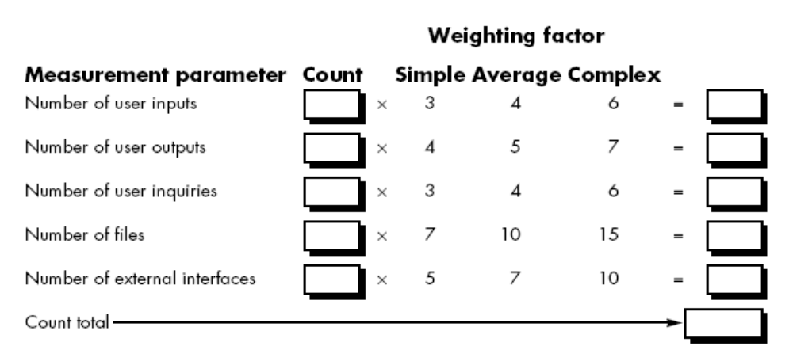
Number of user inputs. Each user input that provides distinct application oriented data to the software is counted. Inputs should be distinguished from inquiries, which are counted separately.
Number of user outputs. Each user output that provides application oriented information to the user is counted. In this context output refers to reports, screens, error messages, etc. Individual data items within a report are not counted separately.
Number of user inquiries. An inquiry is defined as an on-line input that results in the generation of some immediate software response in the form of an on-line output. Each distinct inquiry is counted.
Number of files. Each logical master file (i.e., a logical grouping of data that may be one part of a large database or a separate file) is counted.
Number of external interfaces. All machine readable interfaces (e.g., data files on storage media) that are used to transmit information to another system are counted.

To compute function points (FP), the following relationship is used:

FP = count total * [0.65 + 0.01* Σ(Fi)]

The Fi (i = 1 to 14) are "complexity adjustment values" based on responses to the
following questions :
1. Does the system require reliable backup and recovery?
2. Are data communications required?
3. Are there distributed processing functions?
4. Is performance critical?
5. Will the system run in an existing, heavily utilized operational environment?
6. Does the system require on-line data entry?
7. Does the on-line data entry require the input transaction to be built over multiple
screens or operations?
8. Are the master files updated on-line?
9. Are the inputs, outputs, files, or inquiries complex?
10. Is the internal processing complex?
11. Is the code designed to be reusable?
12. Are conversion and installation included in the design?
13. Is the system designed for multiple installations in different organizations?
14. Is the application designed to facilitate change and ease of use by the user?
Each of these questions is answered using a scale that ranges from 0 (not important or applicable) to 5 (absolutely essential). The constant values in Equation (4-1) and the weighting factors that are applied to information domain counts are determined empirically.

METRICS FOR SOFTWARE QUALITY

Measuring Quality
Although there are many measures of software quality, correctness, maintainability, integrity, and usability provide useful indicators for the project team. Gilb suggests definitions and measures for each.

Correctness. A program must operate correctly or it provides little value to its users. Correctness is the degree to which the software performs its required function. The most common measure for correctness is defects per KLOC, where a defect is defined as a verified lack of conformance to requirements. When considering the overall quality of a software product, defects are those problems reported by a user of the program after the program has been released for general use. For quality assessment purposes, defects are counted over a standard period of time, typically one year.

Maintainability. Software maintenance accounts for more effort than any other software engineering activity. Maintainability is the ease with which a program can be corrected if an error is encountered, adapted if its environment changes, or enhanced if the customer desires a change in requirements. There is no way to measure maintainability directly; therefore, we must use indirect measures. A simple time-oriented metric is mean-time-tochange (MTTC), the time it takes to analyze the change request, design an appropriate modification, implement the change, test it, and distribute the change to all users. On average, programs that are maintainable will have a lower MTTC (for equivalent types of changes) than programs that are not maintainable.

Integrity. Software integrity has become increasingly important in the age of hackers and firewalls. This attribute measures a system's ability to withstand attacks (both accidental and intentional) to its security. The integrity of a system can then be defined as.

integrity = summation [(1 – threat) * (1 – security)]

where threat and security are summed over each type of attack.

Usability. The catch phrase "user-friendliness" has become ubiquitous in discussions of software products. If a program is not user-friendly, it is often doomed to failure, even if the functions that it performs are valuable. Usability is an attempt to quantify user-friendliness and can be measured in terms of four characteristics: (1) the physical and or intellectual skill required to learn the system, (2) the time required to become moderately efficient in the use of the system, (3) the net increase in productivity (over the approach that the system replaces) measured when the system is used by someone who is moderately efficient, and (4) a subjective assessment (sometimes obtained through a questionnaire) of users attitudes toward the system.

Defect Removal Efficiency
A quality metric that provides benefit at both the project and process level is defect removal efficiency (DRE). In essence, DRE is a measure of the filtering ability of quality assurance and control activities as they are applied throughout all process framework
activities. When considered for a project as a whole, DRE is defined in the following manner:

DRE = E/(E + D)

where E is the number of errors found before delivery of the software to the end-user and D is the number of defects found after delivery.
The ideal value for DRE is 1. That is, no defects are found in the software. Realistically, D will be greater than 0, but the value of DRE can still approach 1.

INTEGRATING METRICS WITHIN THE SOFTWARE PROCESS
The majority of software developers still do not measure, and sadly, most have little desire to begin. To avoid this it is desirable to integrate metrics in software process.

METRICS FOR SMALL ORGANIZATIONS
The vast majority of software development organizations have fewer than 20 software people. It is unreasonable, and in most cases unrealistic, to expect that such organizations will develop comprehensive software metrics programs. However, it is reasonable to suggest that software organizations of all sizes measure and then use the resultant metrics to help improve their local software process and the quality and timeliness of the products they produce. requests.” A small organization might select the following set of easily collected measures:
• Time (hours or days) elapsed from the time a request is made until evaluation
is complete, tqueue.
• Effort (person-hours) to perform the evaluation, Weval.
• Time (hours or days) elapsed from completion of evaluation to assignment of change order to personnel, teval Effort (person-hours) required to make the change, Wchange.
• Time required (hours or days) to make the change, tchange.
• Errors uncovered during work to make change, Echange.
• Defects uncovered after change is released to the customer base, Dchange.

ESTABLISHING A SOFTWARE METRICS PROGRAM
The Software Engineering Institute has developed a comprehensive guidebook for establishing a “goal-driven” software metrics program. The guidebook suggests the following steps:
1. Identify your business goals.
2. Identify what you want to know or learn.
3. Identify your subgoals.
4. Identify the entities and attributes related to your subgoals.
5. Formalize your measurement goals.
6. Identify quantifiable questions and the related indicators that you will use to help you achieve your measurement goals.
7. Identify the data elements that you will collect to construct the indicators that help answer your questions.
8. Define the measures to be used, and make these definitions operational.

SUMMARY
Measurement enables managers and practitioners to improve the software process; assist in the planning, tracking, and control of a software project; and assess the quality of the product (software) that is produced. Measures of specific attributes of the process, project, and product are used to compute software metrics. These metrics can be analyzed to provide indicators that guide management and technical actions. Process metrics enable an organization to take a strategic view by providing insight into the effectiveness of a software process. Project metrics are tactical. They enable a project manager to adapt project work flow and technical approach in a real-time manner. Both size- and function-oriented metrics are used throughout the industry. Size oriented metrics use the line of code as a normalizing factor for other measures such as person-months or defects. The function point is derived from measures of the information domain and a subjective assessment of problem complexity. Software quality metrics, like productivity metrics, focus on the process, the project, and the product. By developing and analyzing a metrics baseline for quality, an organization can correct those areas of the software process that are the cause of software defects. Metrics are meaningful only if they have been examined for statistical validity. The control chart is a simple method for accomplishing this and at the same time examining the variation and location of metrics results. Measurement results in cultural change. Data collection, metrics computation, and metrics analysis are the three steps that must be implemented to begin a metrics program. In general, a goal-driven approach helps an organization focus on the right metrics for its business. By creating a metrics baseline—a database containing process and product measurements—software engineers and their managers can gain better insight into the work that they do and the product that they produce.

Unit-5
Software Project Planning

What is it? Software project planning actually encompasses, planning involves estimation—your attempt to determine how much money, how much effort, how many resources, and how much time it will take to build a specific software-based system or product.

Who does it? Software managers—using information solicited from customers and software engineers and software metrics data collected from past projects.
Why is it important? Would you build a house without knowing how much you were about to spend? Of course not, and since most computer-based systems and products cost considerably more to build than a large house, it would seem reasonable to develop an estimate before you start creating the software.

What are the steps? Estimation begins with a description of the scope of the product. Until the scope is “bounded” it’s not possible to develop a meaningful estimate. The problem is then decomposed into a set of smaller problems and each of these is estimated using historical data and experience as guides. It is advisable to generate your estimates using at least two different methods (as a cross check). Problem complexity and risk are considered before a final estimate is made.

What is the work product? A simple table delineating the tasks to be performed, the functions to be implemented, and the cost, effort, and time involved for each is generated. A list of required project resources is also produced. How do I ensure that I’ve done it right? That’s hard, because you won’t really know until the project has been completed. However, if you have experience and follow a systematic approach, generate estimates using solid historical data, create estimation data points using at least two different methods, and factor in complexity and risk, you can feel confident that you’ve given it your best shot

PROJECT PLANNING OBJECTIVES
The objective of software project planning is to provide a framework that enables the manager to make reasonable estimates of resources, cost, and schedule. These estimates are made within a limited time frame at the beginning of a software project and should be updated regularly as the project progresses.

SOFTWARE SCOPE
The first activity in software project planning is the determination of software scope. Software scope describes the data and control to be processed, function, performance, constraints, interfaces, and reliability. Functions described in the statement of scope are evaluated and in some cases refined to provide more detail prior to the beginning of estimation.

Feasibility
Once scope has been identified (with the concurrence of the customer), it is reasonable to ask: “Can we build software to meet this scope? Is the project feasible?”. Three types of feasibility studies are conducted, Economical, technical, Operational.

RESOURCES
The second software planning task is estimation of the resources required to accomplish the software development effort. Figure illustrates development resources as a pyramid. The development environment—hardware and software tools—sits at the foundation of the resources pyramid and provides the infrastructure to support the development effort. At a higher level, we encounter reusable software components—software building blocks that can dramatically reduce development costs and accelerate delivery. At the top of the pyramid is the primary resource—people. Each resource is specified with four characteristics: description of the resource, a statement of availability, time when the resource will be required; duration of time that resource will be applied. The last two characteristics can be viewed as a time window. Availability of the resource for a specified window must be established at the earliest practical time.
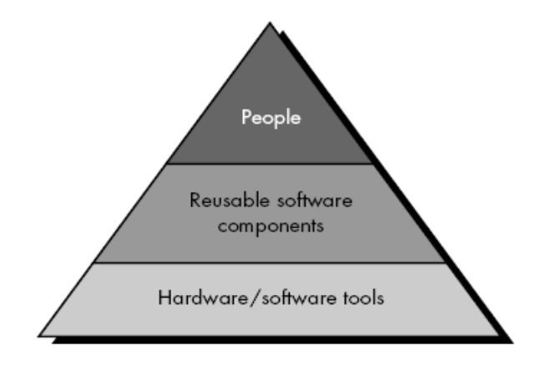
Human Resources
The planner begins by evaluating scope and selecting the skills required to complete development. Both organizational position (e.g., manager, senior software engineer) and specialty (e.g., telecommunications, database, client/server) are specified. For relatively small projects (one person-year or less), a single individual may perform all software engineering tasks, consulting with specialists as required.
The number of people required for a software project can be determined only after an estimate of development effort (e.g., person-months) is made.

Reusable Software Resources. Bennatan suggests four software resource categories that should be considered as planning proceeds:

Off-the-shelf components. Existing software that can be acquired from a third party or that has been developed internally for a past project. COTS (commercial off-the-shelf) components are purchased from a third party, are ready for use on the current project, and have been fully validated.
Full-experience components. Existing specifications, designs, code, or test data developed for past projects that are similar to the software to be built for the current project. Members of the current software team have had full experience in the application area represented by these components. Therefore, modifications required for full-experience components will be relatively
low-risk.

Partial-experience components. Existing specifications, designs, code, or test data developed for past projects that are related to the software to be built for the current project but will require substantial modification. Members of the current software team have only limited experience in the application area represented by these components. Therefore, modifications required for partial-experience components have a fair degree of risk.

New components. Software components that must be built by the software team specifically for the needs of the current project.

Environmental Resources
The environment that supports the software project, often called the software engineering environment (SEE), incorporates hardware and software. Hardware provides a platform that supports the tools (software) required to produce the work products that are an outcome of good software engineering practice.

SOFTWARE PROJECT ESTIMATION
To achieve reliable cost and effort estimates, a number of options arise:
1. Delay estimation until late in the project (obviously, we can achieve
100% accurate estimates after the project is complete!).
2. Base estimates on similar projects that have already been completed.
3. Use relatively simple decomposition techniques to generate project cost and
effort estimates.
4. Use one or more empirical models for software cost and effort estimation.

DECOMPOSITION TECHNIQUES
Software project estimation is a form of problem solving, and in most cases, the problem to be solved (i.e., developing a cost and effort estimate for a software project) is too complex to be considered in one piece. For this reason, we decompose the problem, recharacterizing it as a set of smaller (and hopefully, more manageable) problems.

Software Sizing
The “size” of software to be built can be estimated using a direct measure, LOC, or an indirect measure, FP.

The accuracy of a software project estimate is predicated on a number of things: (1) The degree to which the planner has properly estimated the size of the product to be built; (2) the ability to translate the size estimate into human effort, calendar time, and dollars (a function of the availability of reliable software metrics from past projects); (3) the degree to which the project plan reflects the abilities of the software team; and (4) the stability of product requirements and the environment that supports the software engineering effort.

Putnam and Myers suggest four different approaches to the sizing problem:
“Fuzzy logic” sizing. This approach uses the approximate reasoning techniques that are the cornerstone of fuzzy logic. To apply this approach, the planner must identify the type of application, establish its magnitude on a qualitative scale, and then refine the magnitude within the original range. Although personal experience can be used, the planner should also have access to a historical database of projects8 so that estimates can be compared to actual experience.
Function point sizing. The planner develops estimates of the information domain characteristics.
Standard component sizing. Software is composed of a number of different “standard components” that are generic to a particular application area.
Change sizing. This approach is used when a project encompasses the use of existing software that must be modified in some way as part of a project. The planner estimates the number and type (e.g., reuse, adding code, changing code, deleting code) of modifications that must be accomplished. Using an “effort ratio” for each type of change, the size of the change may be estimated. Putnam and Myers suggest that the results of each of these sizing approaches be combined statistically to create a three-point or expected value estimate. This is accomplished by developing optimistic (low), most likely, and pessimistic (high) values for size.
A three-point or expected value can then be computed. The expected value for the estimation variable (size), S, can be computed as a weighted average of the optimistic (sopt), most likely (sm), and pessimistic (spess) estimates. For example,

S = (sopt + 4sm + spess)/6

An Example of Estimation
As an example of LOC and FP problem-based estimation techniques, let us consider a software package to be developed for a computer-aided design application for mechanical components.

LOC Based Estimation
For our purposes, we assume that further refinement has occurred and that the following major software functions are identified:
• User interface and control facilities (UICF)
• Two-dimensional geometric analysis (2DGA)
• Three-dimensional geometric analysis (3DGA)
• Database management (DBM)
• Computer graphics display facilities (CGDF)
• Peripheral control function (PCF)
• Design analysis modules (DAM)

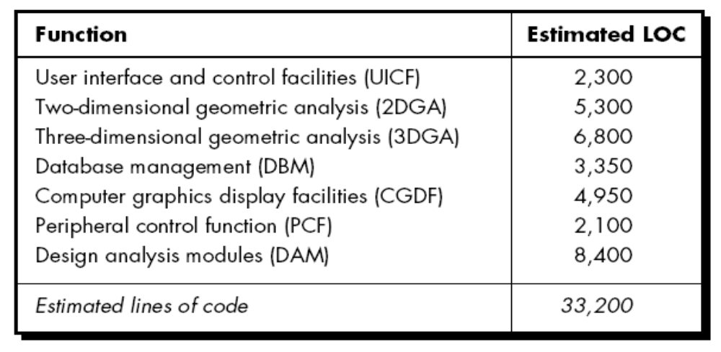

FP Based Estimation
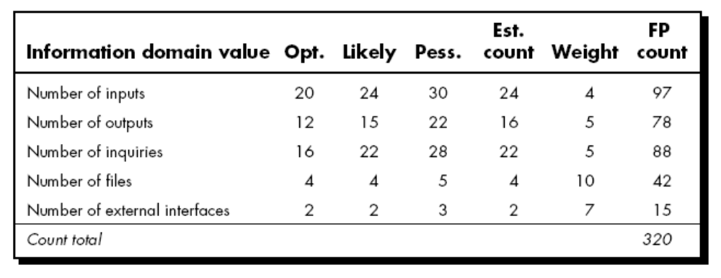
Each of the complexity weighting factors is estimated and the complexity adjustment factor is computed:
Factor Value
Backup and recovery 4
Data communications 2
Distributed processing 0
Performance critical 4
Existing operating environment 3
On-line data entry 4
Input transaction over multiple screens 5
Master files updated on-line 3
Information domain values complex 5
Internal processing complex 5
Code designed for reuse 4
Conversion/installation in design 3
Multiple installations 5
Application designed for change 5

Complexity adjustment factor 1.17

Finally, the estimated number of FP is derived:

FPestimated = count-total x [0.65 + 0.01 *∑ (Fi)]
FPestimated = 375

The organizational average productivity for systems of this type is 6.5 FP/pm. Based on a burdened labor rate of $8000 per month, the cost per FP is approximately $1230. Based on the LOC estimate and the historical productivity data, the total estimated project cost is $461,000 and the estimated effort is 58 person-months.

EMPIRICAL ESTIMATION MODELS

E = A + B x (ev)^{C}

where A, B, and C are empirically derived constants, E is effort in person-months, and ev is the estimation variable (either LOC or FP).

LOC-oriented estimation models proposed in the literature are

E = 5.2 x (KLOC)0.91 Walston-Felix model
E = 5.5 + 0.73 x (KLOC)1.16 Bailey-Basili model
E = 3.2 x (KLOC)1.05 Boehm simple model
E = 5.288 x (KLOC)1.047 Doty model for KLOC > 9

FP-oriented models have also been proposed. These include

E = _13.39 + 0.0545 FP Albrecht and Gaffney model
E = 60.62 x 7.728 x 10-8 FP3 Kemerer model
E = 585.7 + 15.12 FP Matson, Barnett, and Mellichamp model

THE MAKE/BUY DECISION
In many software application areas, it is often more cost effective to acquire than develop computer software. Software engineering managers are faced with a make/buy decision that can be further complicated by a number of acquisition options: (1) software may be purchased (or licensed) off-the-shelf, (2) “fullexperience” or “partial-experience” software components may be acquired and then modified and integrated to meet specific needs, or (3) software may be custom built by an outside contractor to meet the purchaser's specifications. Decision tree is as follows.

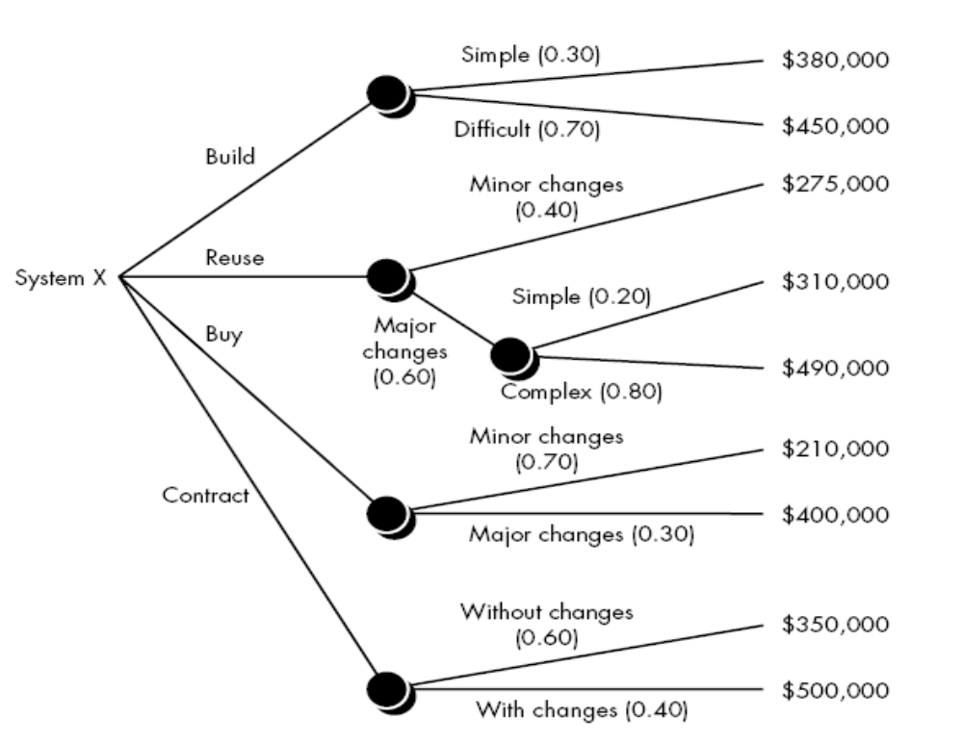

The expected value for cost, computed along any branch of the decision tree, is

expected cost = _ (path probability)i x (estimated path cost)i

where i is the decision tree path. For the build path,

expected cost_{build} = 0.30 ($380K) + 0.70 ($450K) = $429K

similarly for other paths the cost is:

expected costre_{use} = 0.40 ($275K) + 0.60 [0.20($310K) + 0.80($490K)] = $382K
expected cost_{buy} = 0.70($210K) + 0.30($400K)] = $267K
expected cost_{contract} = 0.60($350K) + 0.40($500K)] = $410K

Based on the probability and projected costs that have been noted in Figure the lowest expected cost is the "buy" option.

Outsourcing
Sooner or later, every company that develops computer software asks a fundamental question: “Is there a way that we can get the software and systems we need at a lower price?” The answer to this question is not a simple one, and the emotional discussions
that occur in response to the question always lead to a single word: outsourcing. In concept, outsourcing is extremely simple. Software engineering activities are contracted to a third party who does the work at lower cost and, hopefully, higher quality. Software work conducted within a company is reduced to a contract management activity. The decision to outsource can be either strategic or tactical. At the strategic level, business managers consider whether a significant portion of all software work can be contracted to others. At the tactical level, a project manager determines whether part or all of a project can be best accomplished by subcontracting the software work. Regardless of the breadth of focus, the outsourcing decision is often a financial one.

SUMMARY
The software project planner must estimate three things before a project begins: how long it will take, how much effort will be required, and how many people will be involved. In addition, the planner must predict the resources (hardware and software) that will be required and the risk involved. The statement of scope helps the planner to develop estimates using one or more techniques that fall into two broad categories: decomposition and empirical modeling. Decomposition techniques require a delineation of major software functions, followed by estimates of either (1) the number of LOC, (2) selected values within the information domain, (3) the number of person-months required to implement each function, or (4) the number of person-months required for each software engineering activity. Empirical techniques use empirically derived expressions for effort and time to predict these project quantities. Automated tools can be used to implement a specific empirical model. Accurate project estimates generally use at least two of the three techniques just noted. By comparing and reconciling estimates derived using different techniques, the planner is more likely to derive an accurate estimate. Software project estimation can never be an exact science, but a combination of good historical data and systematic techniques can improve estimation accuracy.

Unit-6

Risk analysis and Management

What is it? Risk analysis and management are a series of steps that help a software team to understand and manage uncertainty. Many problems
can plague a software project. A risk is a potential problem—it might happen, it might not. But, regardless of the outcome, it’s a really good
idea to identify it, assess its probability of occurrence, estimate its impact, and establish a contingency plan should the problem actually occur.
Who does it? Everyone involved in the software process—managers, software engineers, and customers participate in risk analysis and management.

REACTIVE VS. PROACTIVE RISK STRATEGIES.

Reactive – Think of it when it occurs.
Proactive – Think before it occurs.

SOFTWARE RISKS
Although there has been considerable debate about the proper definition for software risk, there is general agreement that risk always involves two characteristics:

• Uncertainty—the risk may or may not happen; that is, there are no 100% probable risks.
• Loss—if the risk becomes a reality, unwanted consequences or losses will occur.

When risks are analyzed, it is important to quantify the level of uncertainty and the degree of loss associated with each risk. To accomplish this, different categories of risks are considered.

Project risks threaten the project plan. That is, if project risks become real, it is likely that project schedule will slip and that costs will increase. Project risks identify potential budgetary, schedule, personnel (staffing and organization), resource, customer, and requirements problems and their impact on a software project. Project complexity, size, and the degree of structural uncertainty were also defined as project (and estimation) risk factors.

Technical risks threaten the quality and timeliness of the software to be produced. If a technical risk becomes a reality, implementation may become difficult or impossible. Technical risks identify potential design, implementation, interface, verification, and maintenance problems. In addition, specification ambiguity, technical uncertainty, technical obsolescence, and "leading-edge" technology are also risk factors. Technical risks occur because the problem is harder to solve than we thought it would be.

Business risks threaten the viability of the software to be built. Business risks often jeopardize the project or the product. Candidates for the top five business risks are (1) building a excellent product or system that no one really wants (market risk), (2) building a product that no longer fits into the overall business strategy for the company (strategic risk), (3) building a product that the sales force doesn't understand how to sell, (4) losing the support of senior management due to a change in focus or a change in people (management risk), and (5) losing budgetary or personnel commitment (budget risks). It is extremely important to note that simple categorization won't always work. Some risks are simply unpredictable in advance.

RISK IDENTIFICATION
Risk identification is a systematic attempt to specify threats to the project plan (estimates, schedule, resource loading, etc.). By identifying known and predictable risks, the project manager takes a first step toward avoiding them when possible and controlling them when necessary.
There are two distinct types of risks generic risks and product-specific risks. Generic risks are a potential threat to every software project. Product-specific risks can be identified only by those with a clear understanding of the technology, the people, and the environment that is specific to the project at hand. To identify product-specific risks, the project plan and the software statement of scope are examined and an answer to the following question is developed: "What special characteristics of this product may threaten our project plan?" One method for identifying risks is to create a risk item checklist. The checklist can be used for risk identification and focuses on some subset of known and predictable risks in the following generic subcategories:

• Product size—risks associated with the overall size of the software to be built or modified.

• Business impact—risks associated with constraints imposed by management or the marketplace.

• Customer characteristics—risks associated with the sophistication of the customer and the developer's ability to communicate with the customer in a timely manner.

• Process definition—risks associated with the degree to which the software process has been defined and is followed by the development organization.

• Development environment—risks associated with the availability and quality of the tools to be used to build the product.

• Technology to be built—risks associated with the complexity of the system to be built and the "newness" of the technology that is packaged by the system.

• Staff size and experience—risks associated with the overall technical and project experience of the software engineers who will do the work. The risk item checklist can be organized in different ways. Questions relevant to each of the topics can be answered for each software project. The answers to these questions allow the planner to estimate the impact of risk. A different risk item checklist format simply lists characteristics that are relevant to each generic subcategory. Finally, a set of “risk components and drivers" are listed along with their probability of occurrence. Drivers for performance, support, cost, and schedule are discussed in answer to later questions.

RISK PROJECTION
Risk projection, also called risk estimation, attempts to rate each risk in two ways—the likelihood or probability that the risk is real and the consequences of the problems associated with the risk, should it occur.

Developing a Risk Table
A risk table provides a project manager with a simple technique for risk projection. A sample risk table is illustrated.

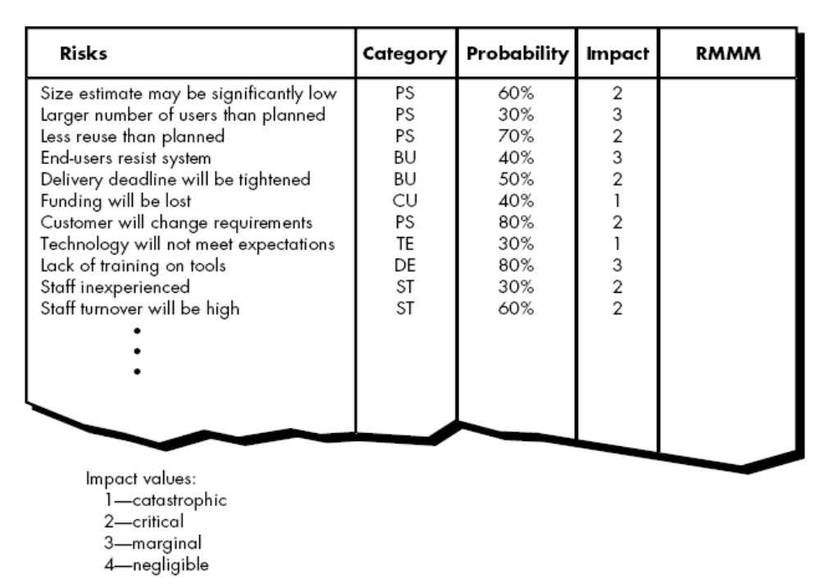

Risk Exposure
The overall risk exposure, RE, is determined using the following relationship

RE = P x C

where P is the probability of occurrence for a risk, and C is the the cost to the project should the risk occur.

For example, assume that the software team defines a project risk in the following manner:

Risk identification. Only 70 percent of the software components scheduled for reuse will, in fact, be integrated into the application. The remaining functionality will have to be custom developed.

Risk probability. 80% (likely).

Risk impact. 60 reusable software components were planned. If only 70 percent can be used, 18 components would have to be developed from scratch (in addition to other custom software that has been scheduled for development). Since the average component is 100 LOC and local data indicate that the software engineering cost for each LOC is $14.00, the overall cost (impact) to develop the components would be 18 x 100 x 14 = $25,200.

Risk exposure. RE = 0.80 x 25,200 ~ $20,200.

RISK MITIGATION, MONITORING, AND MANAGEMENT
All of the risk analysis activities presented to this point have a single goal—to assist the project team in developing a strategy for dealing with risk. An effective strategy must consider three issues:
• risk avoidance
• risk monitoring
• risk management and contingency planning
If a software team adopts a proactive approach to risk, avoidance is always the best strategy. This is achieved by developing a plan for risk mitigation. For example, assume that high staff turnover is noted as a project risk, r1. Based on past history and management intuition, the likelihood, l1, of high turnover is estimated to be 0.70 (70 percent, rather high) and the impact, x1, is projected at level 2. That is, high turnover will have a critical impact on project cost and schedule.

To mitigate this risk, project management must develop a strategy for reducing turnover. Among the possible steps to be taken are
• Meet with current staff to determine causes for turnover (e.g., poor working conditions, low pay, competitive job market).
• Mitigate those causes that are under our control before the project starts.
• Once the project commences, assume turnover will occur and develop techniques to ensure continuity when people leave.
• Organize project teams so that information about each development activity is widely dispersed.
• Define documentation standards and establish mechanisms to be sure that documents are developed in a timely manner.
• Conduct peer reviews of all work (so that more than one person is "up to speed”).
• Assign a backup staff member for every critical technologist.
As the project proceeds, risk monitoring activities commence. The project manager monitors factors that may provide an indication of whether the risk is becoming more or less likely.

In the case of high staff turnover, the following factors can be monitored:
• General attitude of team members based on project pressures.
• The degree to which the team has jelled.
• Interpersonal relationships among team members.
• Potential problems with compensation and benefits.
• The availability of jobs within the company and outside it.

In addition to monitoring these factors, the project manager should monitor the effectiveness of risk mitigation steps. For example, a risk mitigation step noted here called for the definition of documentation standards and mechanisms to be sure that documents are developed in a timely manner. This is one mechanism for ensuring continuity, should a critical individual leave the project. The project manager should monitor documents carefully to ensure that each can stand on its own and that each imparts information that would be necessary if a newcomer were forced to join the software team somewhere in the middle of the project. Risk management and contingency planning assumes that mitigation efforts have failed and that the risk has become a reality.

THE RMMM PLAN
A risk management strategy can be included in the software project plan or the risk management steps can be organized into a separate Risk Mitigation, Monitoring and Management Plan. The RMMM plan documents all work performed as part of risk analysis and is used by the project manager as part of the overall project plan.

SUMMARY
Whenever a lot is riding on a software project, common sense dictates risk analysis. And yet, most software project managers do it informally and superficially, if they do it at all. The time spent identifying, analyzing, and managing risk pays itself back in many ways: less upheaval during the project, a greater ability to track and control a project, and the confidence that comes with planning for problems before they occur.

Unit-7

Project Scheduling and Tracking
What is it? You’ve selected an appropriate process model, you’ve identified the software engineering tasks that have to be performed, you estimated the amount of work and the number of people, you know the deadline, you’ve even considered the risks. Now it’s time to connect the dots. That is, you have to create a network of software engineering tasks that will enable you to get the job done on time. Once the network is created, you have to assign responsibility for each task, make sure it gets done, and adapt the network as risks become reality. In a nutshell, that’s software project scheduling and tracking.

Who does it? At the project level, software project managers using information solicited from software engineers. At an individual level, software engineers themselves.

BASIC CONCEPTS
Although there are many reasons why software is delivered late, most can be traced to one or more of the following root causes:
• An unrealistic deadline established by someone outside the software development group and forced on managers and practitioner's within the group.
• Changing customer requirements that are not reflected in schedule changes.
• An honest underestimate of the amount of effort and/or the number of resources that will be required to do the job.
• Predictable and/or unpredictable risks that were not considered when the project commenced.
• Technical difficulties that could not have been foreseen in advance.
• Human difficulties that could not have been foreseen in advance.
• Miscommunication among project staff that results in delays.
• A failure by project management to recognize that the project is falling behind schedule and a lack of action to correct the problem.

DEFINING A TASK SET FOR THE SOFTWARE PROJECT
No single set of tasks is appropriate for all projects. The set of tasks that would be appropriate for a large, complex system would likely be perceived as overkill for a small, relatively simple software product. Therefore, an effective software process should define a collection of task sets, each designed to meet the needs of different types of projects. Most software organizations encounter the following projects:

1. Concept development projects that are initiated to explore some new business concept or application of some new technology.

2. New application development projects that are undertaken as a consequence of a specific customer request.

3. Application enhancement projects that occur when existing software undergoes major modifications to function, performance, or interfaces that are observable by the end-user.

4. Application maintenance projects that correct, adapt, or extend existing software in ways that may not be immediately obvious to the end-user.

5. Reengineering projects that are undertaken with the intent of rebuilding an existing (legacy) system in whole or in part.

DEFINING A TASK NETWORK
A task network, also called an activity network, is a graphic representation of the task flow for a project.

SCHEDULING
Scheduling of a software project does not differ greatly from scheduling of any multitask engineering effort. Therefore, generalized project scheduling tools and techniques can be applied with little modification to software projects. Program evaluation and review technique (PERT) and critical path method (CPM) are two project scheduling methods that can be applied to software development..

Timeline Charts (Gant Chart)

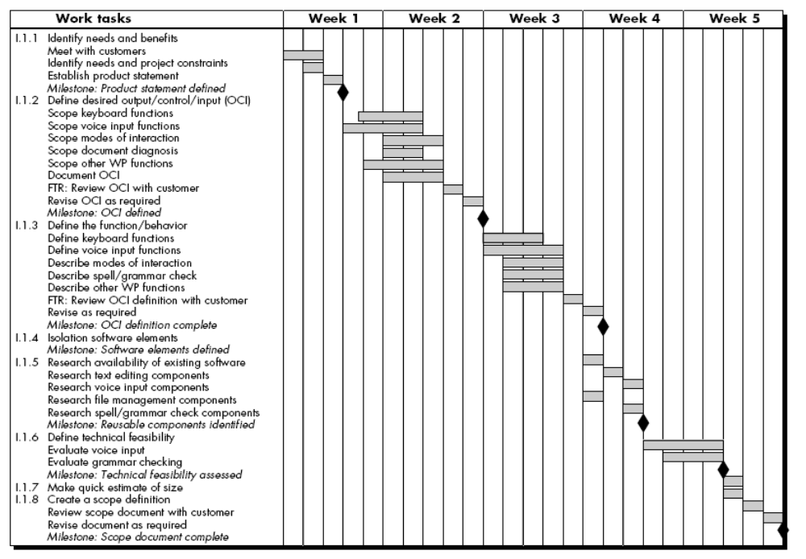

SUMMARY
Scheduling is the culmination of a planning activity that is a primary component of software project management. When combined with estimation methods and risk analysis, scheduling establishes a road map for the project manager. Scheduling begins with process decomposition. The characteristics of the project are used to adapt an appropriate task set for the work to be done. A task network
depicts each engineering task, its dependency on other tasks, and its projected duration. The task network is used to compute the critical path, a timeline chart and a variety of project information. Using the schedule as a guide, the project manager can track and control each step in the software process.

Unit-8

Software Quality Assurance
What is it? It’s not enough to talk the talk by saying that software quality is important, you have to (1) explicitly define what is meant when
you say “software quality,” (2) create a set of activities that will help ensure that every software engineering work product exhibits high
quality, (3) perform quality assurance activities on every software project, (4) use metrics to develop strategies for improving your software
process and, as a consequence, the quality of the end product.

Who does it? Everyone involved in the software engineering process is responsible for quality.

QUALITY CONCEPTS

The American Heritage Dictionary defines quality as “a characteristic or attribute of something.”

Quality Control
Variation control may be equated to quality control. But how do we achieve quality control? Quality control involves the series of inspections, reviews, and tests used throughout the software process to ensure each work product meets the requirements placed upon it. Quality control includes a feedback loop to the process that created the work product. The combination of measurement and feedback allows us to tune the process when the work products created fail to meet their specifications. This approach views quality control as part of the manufacturing process. Quality control activities may be fully automated, entirely manual, or a combination of automated tools and human interaction. A key concept of quality control is that all work products have defined, measurable specifications to which we may compare the output of each process. The feedback loop is essential to minimize the defects produced.

Quality Assurance
Quality assurance consists of the auditing and reporting functions of management. The goal of quality assurance is to provide management with the data necessary to be informed about product quality, thereby gaining insight and confidence that product quality is meeting its goals. Of course, if the data provided through quality assurance identify problems, it is management’s responsibility to address the problems and apply the necessary resources to resolve quality issues.

Cost of Quality
The cost of quality includes all costs incurred in the pursuit of quality or in performing quality-related activities. Cost of quality studies are conducted to provide a baseline for the current cost of quality, identify opportunities for reducing the cost of quality, and provide a normalized basis of comparison. The basis of normalization is almost always dollars. Once we have normalized quality costs on a dollar basis, we have the necessary data to evaluate where the opportunities lie to improve our processes. Furthermore, we can evaluate the effect of changes in dollar-based terms. Quality costs may be divided into costs associated with prevention, appraisal, and failure. Prevention costs include
• quality planning
• formal technical reviews

• test equipment
• training

Appraisal costs include activities to gain insight into product condition the “first time through” each process. Examples of appraisal costs include
• in-process and interprocess inspection
• equipment calibration and maintenance
• testing

Failure costs are those that would disappear if no defects appeared before shipping a product to customers. Failure costs may be subdivided into internal failure costs and external failure costs. Internal failure costs are incurred when we detect a defect in our product prior to shipment. Internal failure costs include
• rework
• repair
• failure mode analysis

External failure costs are associated with defects found after the product has been shipped to the customer. Examples of external failure costs are
• complaint resolution
• product return and replacement
• help line support
• warranty work

SOFTWARE QUALITY ASSURANCE
Even the most jaded software developers will agree that high-quality software is an important goal. But how do we define quality? A wag once said, "Every program does something right, it just may not be the thing that we want it to do." Many definitions of software quality have been proposed in the literature. For our purposes, software quality is defined as “conformance to explicitly stated functional and performance requirements, explicitly documented development standards, and implicit characteristics that are expected of all professionally developed software”.

SQA Activities
- Prepares an SQA plan for a project.
- Participates in the development of the project’s software process description.
- Reviews software engineering activities to verify compliance with the defined software process.
- Audits designated software work products to verify compliance with those defined as part of the software process.
- Ensures that deviations in software work and work products are documented and handled according to a documented procedure.
- Records any noncompliance and reports to senior management.

FORMAL TECHNICAL REVIEWS
A formal technical review is a software quality assurance activity performed by software engineers (and others). The objectives of the FTR are:-
(1) To uncover errors in function, logic, or implementation for any representation of the software.
(2) To verify that the software under review meets its requirements.

(3) To ensure that the software has been represented according to predefined standards.
(4) to achieve software that is developed in a uniform manner.
(5) to make projects more manageable.

The Review Meeting
Regardless of the FTR format that is chosen, every review meeting should abide by the following constraints:

• Between three and five people (typically) should be involved in the review.
• Advance preparation should occur but should require no more than two hours of work for each person.
• The duration of the review meeting should be less than two hours.

Review Reporting and Record Keeping
During the FTR, a reviewer (the recorder) actively records all issues that have been raised. These are summarized at the end of the review meeting and a review issues list is produced. In addition, a formal technical review summary report is completed. A review summary report answers three questions:
1. What was reviewed?
2. Who reviewed it?
3. What were the findings and conclusions?

Review Guidelines
1. Review the product, not the producer.
2. Set an agenda and maintain it.
3. Limit debate and rebuttal..
4. Enunciate problem areas, but don't attempt to solve every problem noted.
5. Take written notes.
6. Limit the number of participants and insist upon advance preparation..
7. Develop a checklist for each product that is likely to be reviewed.
8. Allocate resources and schedule time for FTRs.
9. Conduct meaningful training for all reviewers.
10. Review your early reviews.

STATISTICAL SOFTWARE QUALITY ASSURANCE
Statistical quality assurance reflects a growing trend throughout industry to become more quantitative about quality. For software, statistical quality assurance implies the following steps:
1. Information about software defects is collected and categorized.
2. An attempt is made to trace each defect to its underlying cause (e.g., nonconformance to specifications, design error, violation of standards, poor communication with the customer).
3. Using the Pareto principle (80 percent of the defects can be traced to 20 percent of all possible causes), isolate the 20 percent (the "vital few").
4. Once the vital few causes have been identified, move to correct the problems that have caused the defects.

SOFTWARE RELIABILITY
Software reliability is defined in statistical terms as "the probability of failure-free operation of a computer program in a specified environment for a specified time"

Measures of Reliability and Availability
If we consider a computer-based system, a simple measure of reliability is meantime between-failure (MTBF), where

MTBF = MTTF + MTTR

The acronyms MTTF and MTTR are mean-time-to-failure and mean-time-to-repair, respectively.

Software availability is the probability that a program is operating according to requirements at a given point in time and is defined as

Availability = [MTTF/(MTTF + MTTR)] * 100%

THE SQA PLAN
The SQA Plan provides a road map for instituting software quality assurance. Developed by the SQA group, the plan serves as a template for SQA activities that are instituted for each software project. The documentation section describes (by reference) each of the work products produced as part of the software process. These include :

• Project documents (e.g., project plan)
• Models (e.g., ERDs, class hierarchies)
• Technical documents (e.g., specifications, test plans)
• user documents (e.g., help files)
In addition, this section defines the minimum set of work products that are acceptable to achieve high quality.

SUMMARY
Software quality assurance is an umbrella activity that is applied at each step in the software process. SQA encompasses procedures for the effective application of methods and tools, formal technical reviews, testing strategies and techniques, poka-yoke devices, procedures for change control, procedures for assuring compliance to standards, and measurement and reporting mechanisms.

Unit-9

Software Configuration Management
What is it? When you build computer software, change happens. And because it happens, you need to control it effectively. Software configuration management (SCM) is a set of activities designed to control change by identifying the work products that are likely to change, establishing relationships among them, defining mechanisms for managing different versions of these work products, controlling the changes imposed, and auditing and reporting on the changes made.

Who does it? Everyone involved in the software engineering process is involved with SCM to some extent, but specialized support positions are sometimes created to manage the SCM process.

Software Configuration Items
We have already defined a software configuration item as information that is created as part of the software engineering process. In the extreme, a SCI could be considered to be a single section of a large specification or one test case in a large suite of tests. More realistically, an SCI is a document, a entire suite of test cases, or a named program component (e.g., a C++ function or an Ada package).

VERSION CONTROL
Version control combines procedures and tools to manage different versions of configuration objects that are created during the software process. One representation of the different versions of a system is the evolution graph presented in Figure.

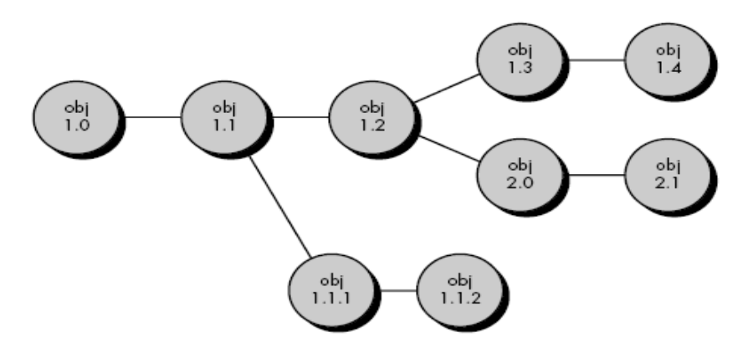

Another way to conceptualize the relationship between entities, variants and versions (revisions) is to represent them as an object pool as shown in figure. 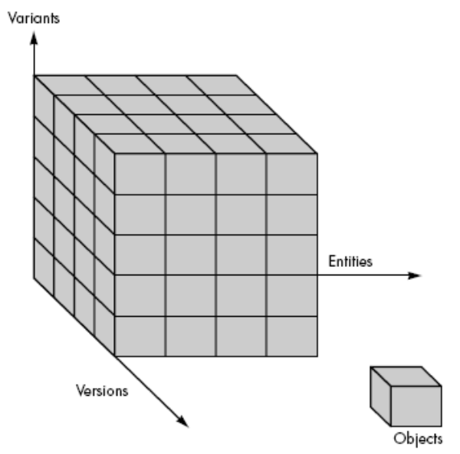

CHANGE CONTROL

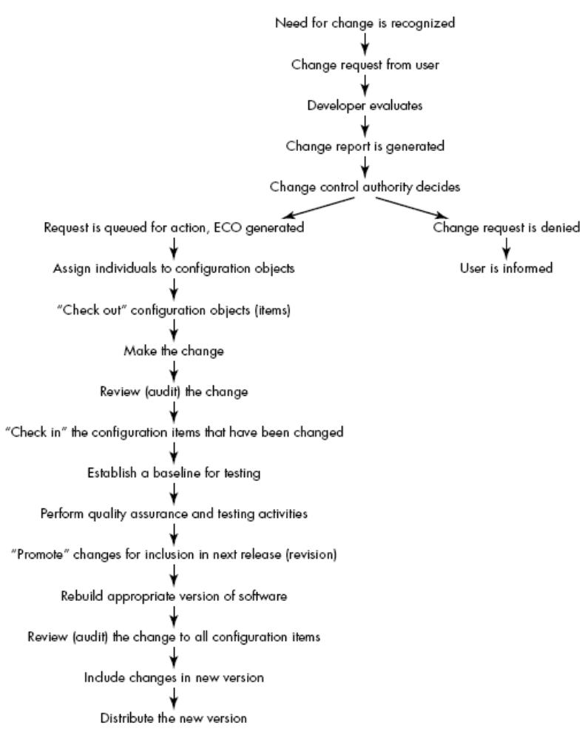

CONFIGURATION AUDIT
A software configuration audit complements the formal technical review by assessing a configuration object for characteristics that are generally not considered during review. The audit asks and answers the following questions:

1. Has the change specified in the ECO been made? Have any additional modifications been incorporated?

2. Has a formal technical review been conducted to assess technical correctness?

3. Has the software process been followed and have software engineering standards been properly applied?

4. Has the change been "highlighted" in the SCI? Have the change date and change author been specified? Do the attributes of the configuration object reflect the change?

5. Have SCM procedures for noting the change, recording it, and reporting it been followed?

6. Have all related SCIs been properly updated?

In some cases, the audit questions are asked as part of a formal technical review. However, when SCM is a formal activity, the SCM audit is conducted separately by the quality assurance group.

SUMMARY
Software configuration management is an umbrella activity that is applied throughout the software process. SCM identifies, controls, audits, and reports modifications that invariably occur while software is being developed and after it has been released to a customer. All information produced as part of software engineering becomes part of a software configuration. The configuration is organized in a manner that enables orderly control of change. The software configuration is composed of a set of interrelated objects, also called software configuration items, that are produced as a result of some software engineering activity. In addition to documents, programs, and data, the development environment that is used to create software can also be placed under configuration control. Once a configuration object has been developed and reviewed, it becomes a baseline. Changes to a baselined object result in the creation of a new version of that object. The evolution of a program can be tracked by examining the revision history of all configuration objects. Basic and composite objects form an object pool from which variants and versions are created. Version control is the set of procedures and tools for managing the use of these objects. Change control is a procedural activity that ensures quality and consistency as changes are made to a configuration object. The change control process begins with a change request, leads to a decision to make or reject the request for change, and culminates with a controlled update of the SCI that is to be changed.

Unit-10

System Engineering
What is it? Before software can be engineered, the ”system” in which it resides must be understood. To accomplish this, the overall objective of
the system must be determined; the role of hardware, software, people, database, procedures, and other system elements must be identified; and
operational requirements must be elicited, analyzed, specified, modeled, validated, and managed. These activities are the foundation of system
engineering.

Who does it? A system engineer works to understand system requirements by working with the customer, future users, and other stakeholders.

COMPUTER-BASED SYSTEMS
Computer-based system makes use of a variety of system elements:
Software. Computer programs, data structures, and related documentation that serve to effect the logical method, procedure, or control that is required.
Hardware. Electronic devices that provide computing capability, the interconnectivity devices (e.g., network switches, telecommunications devices) that enable the flow of data, and electromechanical devices (e.g., sensors, motors, pumps) that provide external world function.
People. Users and operators of hardware and software.
Database. A large, organized collection of information that is accessed via software.
Documentation. Descriptive information (e.g., hardcopy manuals, on-line help files, Web sites) that portrays the use and/or operation of the system.
Procedures. The steps that define the specific use of each system element or the procedural context in which the system resides.

THE SYSTEM ENGINEERING HIERARCHY
The system engineering process usually begins with a “world view.” That is, the entire business or product domain is examined to ensure that the proper business or technology context can be established. The world view is refined to focus more fully on specific domain of interest. Within a specific domain, the need for targeted system elements (e.g., data, software, hardware, people) is analyzed. Finally, the analysis, design, and construction of a targeted system element is initiated. At the top of the hierarchy, a very broad context is established and, at the bottom, detailed technical activities, performed by the relevant engineering discipline (e.g., hardware or software engineering), are conducted.

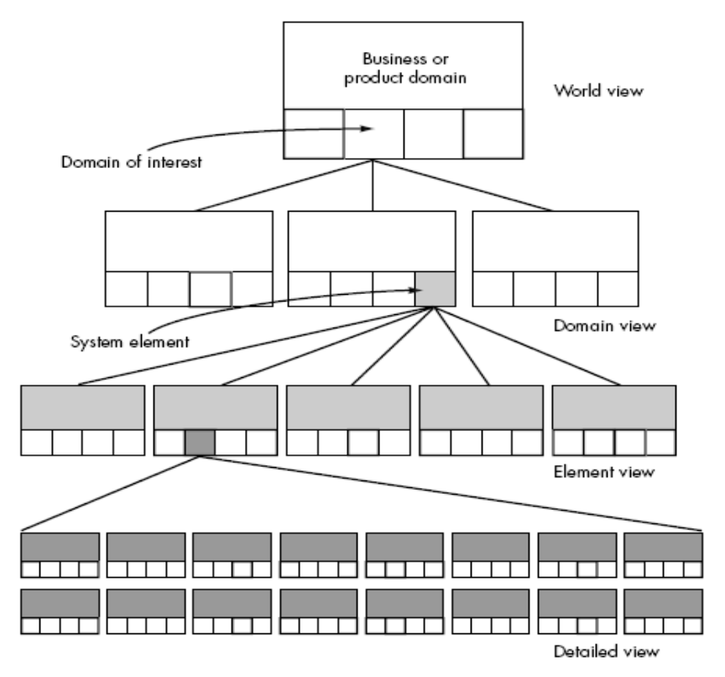

BUSINESS PROCESS ENGINEERING
The goal of business process engineering (BPE) is to define architectures that will enable a business to use information effectively.

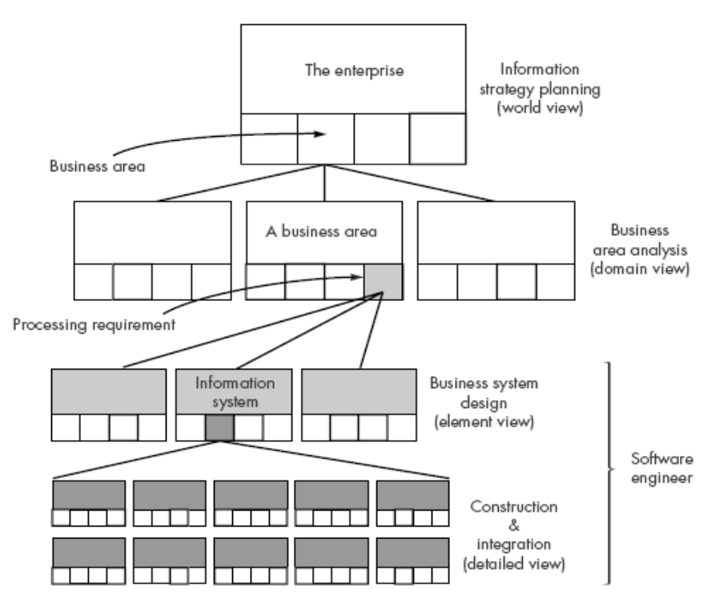

PRODUCT ENGINEERING
The goal of product engineering is to translate the customer’s desire for a set of defined capabilities into a working product.

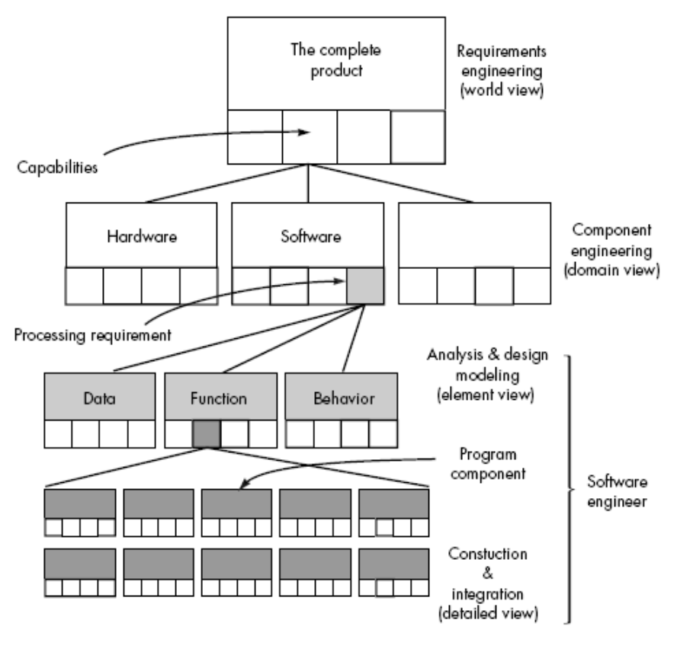
REQUIREMENTS ENGINEERING
The outcome of the system engineering process is the specification of a computer based system or product at the different levels. The requirements engineering process can be described in five distinct steps:
• Requirements elicitation
• Requirements analysis and negotiation
• Requirements specification
• System modeling
• Requirements validation
• Requirements management

SUMMARY
A high-technology system encompasses a number of elements: software, hardware, people, database, documentation, and procedures. System engineering helps to translate a customer’s needs into a model of a system that makes use of one or more of these elements. System engineering begins by taking a “world view.” A business domain or product is analyzed to establish all basic business requirements. Focus is then narrowed to a “domain view,” where each of the system elements is analyzed individually. Each element is allocated to one or more engineering components, which are then addressed by the relevant engineering discipline.

Unit-11

Analysis Concepts and Principles
What is it? The overall role of software in a larger system is identified during system engineering. However, it’s necessary to take a harder look at software’s role to understand the specific requirements that must be achieved to build high-quality software. That’s the job of software requirements analysis. To perform the job properly, you should follow a set of underlying concepts and principles.

Who does it? Generally, a software engineer performs requirements analysis. However, for complex business applications, a “system analyst” trained in the business aspects of the application domain may perform the task.

REQUIREMENTS ANALYSIS
Requirements analysis is a software engineering task that bridges the gap between system level requirements engineering and software design.

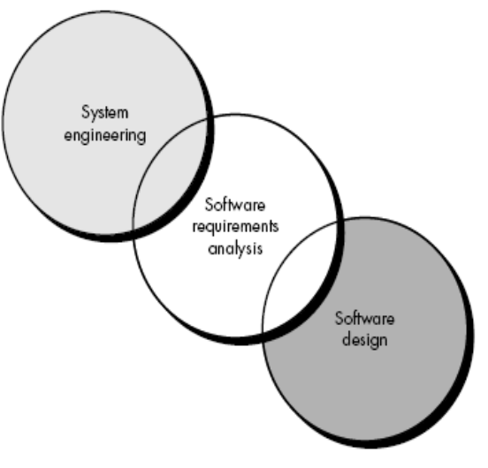

Facilitated Application Specification Techniques
Too often, customers and software engineers have an unconscious "us and them" mind-set. Rather than working as a team to identify and refine requirements, each constituency defines its own "territory" and communicates through a series of memos, formal position papers, documents, and question and answer sessions. History has shown that this approach doesn't work very well. Misunderstandings abound, important information is omitted, and a successful working relationship is never established. It is with these problems in mind that a number of independent investigators have developed a team-oriented approach to requirements gathering that is applied during early stages of analysis and specification. Called facilitated application specification techniques (FAST), this approach encourages the creation of a joint team of customers and developers who work together to identify the problem, propose elements of the solution, negotiate different approaches and specify a preliminary set of solution requirements. FAST has been used predominantly by the information systems community, but the technique offers potential for improved communication in applications of all kinds.
Many different approaches to FAST have been proposed. Each makes use of a slightly different scenario, but all apply some variation on the following basic guidelines:

• A meeting is conducted at a neutral site and attended by both software engineers and customers.

• Rules for preparation and participation are established.
• An agenda is suggested that is formal enough to cover all important points but informal enough to encourage the free flow of ideas.
• A "facilitator" (can be a customer, a developer, or an outsider) controls the meeting.
• A "definition mechanism" (can be work sheets, flip charts, or wall stickers or an electronic bulletin board, chat room or virtual forum) is used.
• The goal is to identify the problem, propose elements of the solution, negotiate different approaches, and specify a preliminary set of solution requirements in an atmosphere that is conducive to the accomplishment of the goal.

Quality Function Deployment
QFD identifies three types of requirements:

Normal requirements. The objectives and goals that are stated for a product or system during meetings with the customer. If these requirements are present, the customer is satisfied. Examples of normal requirements might be requested types of graphical displays, specific system functions, and defined levels of performance.

Expected requirements. These requirements are implicit to the product or system and may be so fundamental that the customer does not explicitly state them. Their absence will be a cause for significant dissatisfaction. Examples of expected requirements are: ease of human/machine interaction, overall operational correctness and reliability, and ease of software installation.

Exciting requirements. These features go beyond the customer’s expectations and prove to be very satisfying when present. For example, word processing software is requested with standard features. The delivered product contains a number of page layout capabilities that are quite pleasing and unexpected.

ANALYSIS PRINCIPLES
Over the past two decades, a large number of analysis modeling methods have been developed. Investigators have identified analysis problems and their causes and have developed a variety of modeling notations and corresponding sets of heuristics to overcome them. Each analysis method has a unique point of view. However, all analysis methods are related by a set of operational principles:
1. The information domain of a problem must be represented and understood.
2. The functions that the software is to perform must be defined.
3. The behavior of the software (as a consequence of external events) must be represented.
4. The models that depict information, function, and behavior must be partitioned in a manner that uncovers detail in a layered (or hierarchical) fashion.
5. The analysis process should move from essential information toward implementation detail.

In addition to these operational analysis principles, Davis suggests a set of guiding principles for requirements engineering:

• Understand the problem before you begin to create the analysis model. There is a tendency to rush to a solution, even before the problem is understood. This often leads to elegant software that solves the wrong problem!

• Develop prototypes that enable a user to understand how human/machine interaction will occur. Since the perception of the quality of software is often based on the perception of the “friendliness” of the interface, prototyping (and the iteration that results) are highly recommended.

• Record the origin of and the reason for every requirement. This is the first step in establishing traceability back to the customer.

• Use multiple views of requirements. Building data, functional, and behavioral models provide the software engineer with three different views. This reduces the likelihood that something will be missed and increases the likelihood that inconsistency will be recognized.

• Rank requirements. Tight deadlines may preclude the implementation of every software requirement. If an incremental process model is applied, those requirements to be delivered in the first increment must be identified.

• Work to eliminate ambiguity. Because most requirements are described in a natural language, the opportunity for ambiguity abounds. The use of formal technical reviews is one way to uncover and eliminate ambiguity. A software engineer who takes these principles to heart is more likely to develop a software specification that will provide an excellent foundation for design.

SPECIFICATION

Specification Principles
Specification, regardless of the mode through which we accomplish it, may be viewed as a representation process. Requirements are represented in a manner that ultimately leads to successful software implementation. A number of specification principles,
adapted from the work of Balzer and Goodman can be proposed:

1. Separate functionality from implementation.

2. Develop a model of the desired behavior of a system that encompasses data and the functional responses of a system to various stimuli from the environment.

3. Establish the context in which software operates by specifying the manner in which other system components interact with software.

4. Define the environment in which the system operates and indicate how “a highly intertwined collection of agents react to stimuli in the environment (changes to objects) produced by those agents” .

5. Create a cognitive model rather than a design or implementation model. The cognitive model describes a system as perceived by its user community.

6. Recognize that “the specifications must be tolerant of incompleteness and augmentable.” A specification is always a model—an abstraction—of some real (or envisioned) situation that is normally quite complex. Hence, it will be incomplete and will exist at many levels of detail.

7. Establish the content and structure of a specification in a way that will enable it to be amenable to change.

The Software Requirements Specification
The Software Requirements Specification is produced at the culmination of the analysis task. The function and performance allocated to software as part of system engineering are refined by establishing a complete information description, a detailed functional description, a representation of system behavior, an indication of performance requirements and design constraints, appropriate validation criteria, and other information pertinent to requirements. The National Bureau of Standards, IEEE (Standard No. 830-1984), and the U.S. Department of Defense have all proposed candidate formats for software requirements specifications (as well as other software engineering documentation).

The Introduction of the software requirements specification states the goals and objectives of the software, describing it in the context of the computer-based system. Actually, the Introduction may be nothing more than the software scope of the planning document. The Information Description provides a detailed description of the problem that the software must solve. Information content, flow, and structure are documented. Hardware, software, and human interfaces are described for external system elements and internal software functions. A description of each function required to solve the problem is presented in the Functional Description. A processing narrative is provided for each function, design constraints are stated and justified, performance characteristics are stated, and one or more diagrams are included to graphically represent the overall structure of the software and interplay among software functions and other system elements.

The Behavioral Description section of the specification examines the operation of the software as a consequence of external events and internally generated control characteristics. Validation Criteria is probably the most important and, ironically, the most often neglected section of the Software Requirements Specification. How do we recognize a successful implementation? What classes of tests must be conducted to validate function, performance, and constraints? We neglect this section because completing it demands a thorough understanding of software requirements—something that we often do not have at this stage. Yet, specification of validation criteria acts as an implicit review of all other requirements. It is essential that time and attention be given to this section.

Finally, the specification includes a Bibliography and Appendix. The bibliography contains references to all documents that relate to the software. These include other software engineering documentation, technical references, vendor literature, and standards. The appendix contains information that supplements the specifications. Tabular data, detailed description of algorithms, charts, graphs, and other material are presented as appendixes.

SUMMARY
Requirement’s analysis is the first technical step in the software process. It is at this point that a general statement of software scope is refined into a concrete specification that becomes the foundation for all software engineering activities that follow. Analysis must focus on the information, functional, and behavioral domains of a partitioned, and representations that depict the essence of requirements and, later, implementation detail, are developed. In many cases, it is not possible to completely specify a problem at an early stage. Prototyping offers an alternative approach that results in an executable model of the software from which requirements can be refined. To properly conduct prototyping special tools and techniques are required. The Software Requirements Specification is developed because of analysis. Review is essential to ensure that the developer and the customer have the same perception of the system. Unfortunately, even with the best of methods, the problem is that the problem keeps changing.

